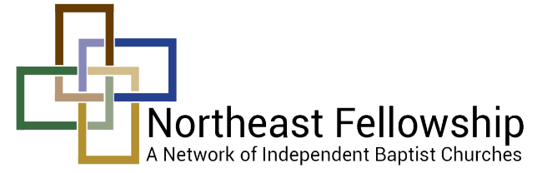
Ladies Advance 2016
Arts & Crafts Vendor Contract
September 23-24
First Baptist Church of Johnson City
Due by September 12, 2016

Name (please print): ___________________________________________________

Address: ____________________________________________________________
PLEASE READ NEW
GUIDELINES

Phone Number: _______________________________________________________

Your Church Name: ___________________________________________________

Items you will be selling: ___________________________________________________________________________________________________________

___________________________________________________________________________________________________________

Conditions and Terms
- We are asking for only Arts & Crafts Vendors, (hand-made items).
- Cost: $10.00 for 8 foot table or $18.00 for 2 – 8 foot tables.
- Contract must be completed, signed and returned with payment by September 12th. Please make checks payable to Northeast Fellowship. Mail contract and payment to 2293 Grand Central Avenue, Horseheads, NY 14845.
- Your contract applications will be processed on a first come first serve basis.
- We reserve the right to select vendors so that we have a broad representation of products.
- Check in/set-up is any time after 4:00 pm. No early set ups please.
- Each vendor will be asked to donate an item for our giveaways, please turn in to Michelle Forman at the conference. Include a card with your name.
- Exhibitors and helpers must also register and attend all sessions for the conference.
- Exhibitors (and any helpers) are asked NOT to sell or sit at your tables during main sessions or workshops. We want to encourage everyone to be in the sessions, not shopping.

By signing this contract you acknowledge that you are responsible to report your sales and pay sales taxes, according to the IRS guidelines. The Ladies Advance is not responsible for any liability for your sales. Please see the information below regarding your responsibility to the IRS. We advise you to contact the IRS or your accountant directly if you have any questions.

Tax Bulletin ST-175 (TB-ST-175) Issue Date: March 26, 2010
Introduction: If you will be making sales in New York State that are subject to sales tax, you must register with the Tax Department and obtain a Certificate of Authority. The Certificate of Authority gives you the right to collect sales tax on your taxable sales and to issue and accept most New York State sales tax exemption certificates.
How often you sell or how much you charge for goods and services does not usually determine whether you need to register for sales tax. For example, if you sell taxable items at a craft fair only once a year, you are required to register, and to collect and remit sales tax, because what you are selling is taxable in New York State. This bulletin explains who is required to register, and what kinds of goods and services are generally subject to tax. Even if you are not required to register with the Tax Department for sales tax purposes, you may be responsible for other taxes or may need other permits or licenses issued by various state agencies. You can find information about other taxes and licenses for your particular type of business by following these links: the Tax Department’s Web page Start or buy a business; and the NYS License Center. For information about the sales tax registration process, see Tax Bulletin How to Register for New York State Sales Tax (TB-ST-360).

Signature: ______________________________________ Date: ___________________________

