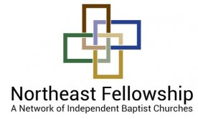
2019 BUSINESS DISPLAY APPLICATION
THANKS for your interest in hosting a business display at a Northeast Fellowship event!
BUSINESS NAME: ____________________________________________________________
YOUR NAME/POSITION: ______________________________________________________
CONTACT INFO: Web Site: ____________________________________________________ E-Mail: ____________________________________________________ Address: ____________________________________________________
DOCTRINE: Our fellowship is based on our commitment to classic Christian doctrine, expressed in our statement at https://nfibc.org/about/our-doctrine. We request your respect to the position of our churches while exhibiting among us. We reserve the right, based on this, to accept or refuse any submitted application.
DONATION: Please send a $100 check payable to “Northeast Fellowship” to Northeast Fellowship / 2293 Grand Central Avenue / Horseheads, NY 14845 for a display area with a 6 – 8 foot table. Thanks for your involvement with our ministry and its events.
May the Lord bless your business, and thanks for your desire to partner with us.

