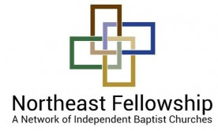
2019 MINISTRY DISPLAY APPLICATION
THANKS for your interest in hosting a ministry display at a Northeast Fellowship event!
MINISTRY NAME: ____________________________________________________________
YOUR NAME/POSITION: _______________________________________________________
CONTACT INFO: Web Site: ____________________________________________________ E-Mail: ____________________________________________________ Address: ____________________________________________________
DOCTRINE: All ministry organizations must express basic agreement with our doctrinal statement, available at https://nfibc.org/about/our-doctrine. Please sign and date here to indicate your agreement: __________________________________
DONATION: Please send a $75 check payable to “Northeast Fellowship” to Northeast Fellowship / 2293 Grand Central Avenue / Horseheads, NY 14845 for a display area with a 6 – 8 foot table. Thanks for your involvement with our ministry and its events.
Thanks for your ministry for Christ and for your desire to partner with us!

