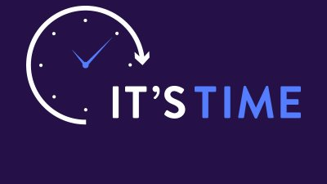 2024 MARRIAGE CAMP

~ Bethany Camp / 1633 Bates Road / Sinclairville, NY ~

Friday-Saturday, June 14-15, 2024

CHURCH NAME & ADDRESS ___________________________________________
GROUP LEADER _____________________________________________________

Husband/Wife Name  (on one line) | Phone Number | E-Mail Address

Mail this form with ONE CHECK payable to “Northeast Fellowship” postmarked by June 3 to:
Northeast Fellowship / Marriage Camp
2293 Grand Central Avenue, Horseheads, NY 14845
Additional Info online at nfibc.org/events/marriage
Contact Info: Brian King (607-365-2169 / bking@nfibc.org)

