


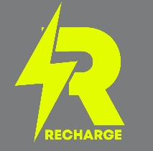
$60 Per Student | Adult if postmarked by APRIL 12, 2027

May 7-8, 2027

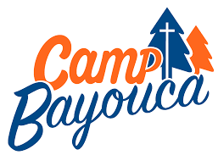

(After April 14, $65 Per Student / Adult)
Price includes all sessions / events, overnight in cabin, 3 Meals & Recharge T-shirt

Mail ONE check for entire group made payable to:
Northeast Fellowship / RECHARGE, 2293 Grand Central Ave, Horseheads, NY 14845
Alternative: To pay by credit card, please visit CampRecharge2027.EZregister.com (fees apply) * Please bring a photocopy of this form to the event. *
CHURCH NAME & TOWN ________________________________________________________________________________
Name (Please write clearly)  ** Indicate group leader please | $ Amount | Guy | Girl | Leader | T  -  Shirt Size
 |  |  |  |  |  | 1 | 2 | 3 | 4 | 5 | 6 | 7
1.
2.
3.
4.
5.
6.
7.
8.
9.
10.
11.
12.
13.
14.
15.
TOTALS

* SEE WORKSHOP TITLES ON PAGE 2

Workshops – Students choose 3

- Encourage One Another
- Greet One Another
- Pray for One Another
- Forgive One Another
- Spur On One Another
- Be Unified with One Another

